TABLE OF CONTENTS

EXECUTIVE SUMMARY 2
VISION STATMENT 3
MISSION STATEMENT 4
INTRODUCTION 5
COMPANY PROFILE 7
CONTENTS OF PROJECT 9
Calculation of Ratios: 10
RATIOS INTERPRETATION 11
Short term Solvency or Liquidity Ratio 11
Asset Utilization Ratio 13
Long Term Solvency or Financial Leverage Ratio 17
Profitability Ratios 19
Market Value Ratios 20
COMPARISION OF BOOK VALUE AND MARKET VALUE OF SHARE PRICE 21
TREND IN CHANGE OF NETINCOME: 22
FIRM TAXBARCKET AND AVERAGE TAX: 22
DIVIDEND POLICY, RETENTION RATE, GROWTH RATE: 23
LAST YEAR YIELD: 24
BREAK EVEN RUPEES: 26
COMPARISON OF REQUIRED RATE OF RETURN WITH ACTUAL RATE OF RETURN: 27
WEIGHTED AVERAGE COST OF CAPITAL: 28
BETA CALCULATION Error! Bookmark not defined.
RECOMMENDATIONS: 30
BIBLIOGRAPHY: 30

EXECUTIVE SUMMARY

Ghribwal Cement Limited is one of the biggest cement manufacturing unit in Pakistan. The production of cement is on large scale and they are planning to increase the production. There main product is ordinary Portland cement. There is a chance of growth for the company as government has imposed ban on import of business. The sale can be increased if proper distribution policy is adopted. This report includes a detailed analysis of financial statements which includes capital structure of the, retention rate and growth of the company. Company was facing losses from the last couple of years so that’s why they were not paying any kind of dividend to its share holders but recently board of directors of company have decided to pay the dividend because they company is starting earning profits. Company performed their operations in mega projects at national level also. This project covers the detailed analysis of each financial dimensions of the company with proper recommendations.

VISION STATMENT

GHARIBWAL has been at the forefront in building a strong and solid Pakistan over the past nearly forty five years. Our brand of cement has endured the test of time which is reflected by its performance in the Mangla Dam, the Qadirabad Barrage, the Rasool/Sulemanki Barrage, and so forth.
GHARIBWAL strives to ensure and maintain its excellence in the field of sales, marketing and distribution of cement by a strong focus on customer satisfaction, a wide network of cement stockiest spanning the Punjab and Azad Kashmir and we are greatly value our patrons for their continued preference and loyalty for our cement.
GHARIBWAL envisions that the administrative and financial reforms instituted by the management in recent years shall be sustained in future periods to ensure the Company’s prosperity and progress.
GHARIBWAL’s cement plant, situated at a significant location in Punjab province, is poised to embrace the latest cement technology through the establishment of a modern, dry process cement plant as its present location, thereby, thrusting its profitability to a higher domain along with achieving all round plant efficiency and cost control.
GHARIBWAL accordingly has focused vision to rank high in performance amongst Pakistan’s top cement producers in the future.

MISSION STATEMENT

GHARIBWAL’s mission is to constantly endeavor for excellence in all spheres of business activity and maintain its market position in key centers of Punjab and Azad Kashmir.

GHARIBWAL’s mission is also to promote mutually satisfactory relationships with our customers and all other stake holders by creating value additions and to construct a strong, durable and forward moving Pakistan.

INTRODUCTION

Ismail Cement Industries Limited was incorporated in Pakistan on December 29, 1960 as a Public Limited Company with Authorized Capital of Rs.50, 000,000. Mr.Naseer A. Shaikh was the first chairman of the company.
The Company appointed M/s Henry Pooley, London as their consulting Engineer and placed orders for the main cement plant (wet process) and machinery with Fives Lille-Cail Paris. The contract for the construction of the factory buildings and foundations was awarded to M/s Gammon (Pakistan) Limited and housing colony was completed by petty contractors.
1963: Financing from International Finance Corporation & Pakistan Industrial Credit and Investment Corporation extended to $3,038,325 and $2,278,744 respectively. In 1965: In the first year of commercial production, the Company earned a net profit of Rs. 6,595,337 (excluding depreciation).
1966: Company announced its first dividend @ 6%. 1970: Last year of eight years of tax holiday expired.
In 1972: Name changed to "GHARIBWAL CEMENT LIMITED"
Management of the Company was taken over by the Central Government on January 3, 1972 under the Economic Reforms Order (presidential Order No.1) of 1972.
1975: Company gave its cement brand name "PAIDAR". In 1978: Company announced

dividend @ 20% to its shareholders. In 1981: Company announced its highest dividend @ 22.50% to its shareholders.
1978:
Company announced dividend @ 20% to its shareholders..
1981:
Company announced its highest dividend @ 22.50% to its shareholders..
1983:
Cement production was 566,526 M.Tons, highest in the history of Company.
1985:
Cement production was 582,427 M.Tons, highest in the history of Company.

PRODUCT:
Gharibwal Cement Limited is principally engaged in production and sale of Ordinary Portland Cement.

COMPANY PROFILE

Board of Directors:
Mr. M. Tousif Peracha (Chairman & Chief Executive)
Mr. A. Rafique Khan (Director)
Mrs. Tabassum Tousif Peracha (Director)
Mr. A. Shoeb Piracha (Director)
Mr. M. Saleem Peracha (Director)
Mr. Aameen Taqi Butt (Director)
Mr. M. Ishaque Khokhar (Director)
Audit Committee:
Mrs. Tabassum Tousif Peracha (Chairman & Member)
Mr. M. Ishaque Khokhar (Member)
Mr. M. Saleem Peracha (Member)
Chief Financial Officer:
Mr. Zulfiqar A. Choudhry (FCA, ACMA)
Company Secretary:
Mr. Abbas Rashid Siddiqi
Statutory Auditors:
Viqar A. Khan (Chartered Accountants)

Internal Auditors:
Aftab Nabi & Co (Chartered Accountants)
Legal Advisor:
International Legal Services
Bankers:
Saudi Pak Commercial Bank Limited
National Bank of Pakistan
United Bank Limited
Muslim Commercial Bank Limited
Citibank N.A.
Habib Bank Limited
PICIC Commercial Bank Limited
Prime Commercial Bank Ltd.
Registered Office:
3-A/3, Gulberg-III, Lahore
Telephone: 042-5871057-58, Fax: 042-5871056
E-Mail: info@gharibwalcement.com
Factory:
Ismailwal, Distt. Chakwal
Shares Registrar:
M/s Corplink (Pvt) Ltd.
Wings Arcade, 1-K, Commercial,
Model Town, Lahore.
Tel: 042-5887262, 5839182
Fax: 042-5869037

CONTENTS OF PROJECT

- Comparison of book value and market value of share price.
- Trend in change of Net Income of the firm in last 3 years.
- Finding firm tax bracket and calculating average tax that firm pays annually.
- Analyzing firm’s dividend policy, retention rate, growth rate, market share and industry position etc.
- Finding firms capital structure and explaining if you think it is optimal or not.
- Calculating last year yield if you invest in this firm, and if you plan to invest in the long run or in short run.
- Calculating your actual rate of return on investing in this firm and required rate of return you expect from this firm from all the methods you have learned in this course (Expected Return, Dividend Discount Model, Infinite dividend payments, CAPM etc.)
- Calculating break-even rupees (if you can) and degree of operating leverage of the firm.
- Finally, comparing your required rate of return from ONE of your calculated methods with the actual rate of return and justifying your comparisons, why you believe this particular method is most reliable for this kind of comparison.
- Last but not the least, making a suggestion, based on your comparison of actual price and calculated price, above investing or not investing in this firm.
- Ratio Analysis

Calculation of Ratios:

 |  |  |  |  |  |  |  |  |  |  |  |  | Years
 |  |  |  |  |  |  |  |  |  |  | 2006 |  | 2005 |  | 2004
 |  |  |  |  |  |  |  |  |  |  | (Rupees in Thousands)
Liquidity Ratio
 | Current ratio |  |  |  |  |  |  |  |  |  | 1.15 |  | 1.67 |  | 0.51
 | Quick Ratio |  |  |  |  |  |  |  |  |  | 0.96 |  | 1.61 |  | 0.43
 | Cash Ratio |  |  |  |  |  |  |  |  |  | 0.23 |  | 0.74 |  | 0.02
 | NWC To Asset |  |  |  |  |  |  |  |  |  | 0.02 |  | 0.12 |  | (0.13)
 | Interval Measure |  |  |  |  |  |  |  |  |  | 238.51 |  | 212.31 |  | 90.65
Asset Utilization Ratio
 | Inventory Turnover |  |  |  |  |  |  |  |  |  | 9.68 |  | 54.55 |  | 29.27
 | Days' Sales in Inventory |  |  |  |  |  |  |  |  |  | 37.71 |  | 6.69 |  | 12.47
 | Receivable Turnover |  |  |  |  |  |  |  |  |  | 12.13 |  | 10.6 |  | 20.67
 | Days' Sales in Receivable |  |  |  |  |  |  |  |  |  | 30.09 |  | 34.44 |  | 17.66
 | Fixed Asset Turnover |  |  |  |  |  |  |  |  |  | 0.63 |  | 1.29 |  | 0.99
 | NWC Turnover |  |  |  |  |  |  |  |  |  | 15.01 |  | 5.16 |  | (5.03)
Financial Leverage Ratios
 | Total Debt Ratio |  |  |  |  |  |  |  |  |  | 0.53 |  | 0.54 |  | 0.96
 | Debt Equity Ratio |  |  |  |  |  |  |  |  |  | 0.22 |  | 0.35 |  | 11.25
 | Equity Multiplier |  |  |  |  |  |  |  |  |  | 2.11 |  | 2.17 |  | 26.9
 | Long Term Debt Ratio |  |  |  |  |  |  |  |  |  | 0.18 |  | 0.26 |  | 0.92
 | TIE Ratio |  |  |  |  |  |  |  |  |  | 5.24 |  | 2.57 |  | 2.09
 | Cash Coverage Ratio |  |  |  |  |  |  |  |  |  | 6.5 |  | 3.69 |  | 3.26
Profitability Ratio
 | Profit Margin |  |  |  |  |  |  |  |  |  | 0.11 |  | 0.13 |  | 0.1
 | Return on Asset |  |  |  |  |  |  |  |  |  | 0.04 |  | 0.08 |  | 0.06
 | Return on Equity |  |  |  |  |  |  |  |  |  | 0.08 |  | 0.17 |  | 1.72
Market Value Ratio
 | Price Earning Ratio |  |  |  |  |  |  |  |  |  | 13.53 |  | 2.78 |  | 2.7
 | Market to Book Value |  |  |  |  |  |  |  |  |  | 1.48 |  | 1.43 |  | 0.09

RATIOS INTERPRETATION

Short term Solvency or Liquidity Ratio
Current ratio:
Current ratio is used to measure short term solvency of a company. Higher current ratio is better especially for short term creditors as suppliers. Current ratio should be at least 1. Gharibwal Cement Company in year 2004 had less than 1 current ratio i.e. 0.51 times which was not good sign and its NWC was negative. But in year 2005 and 2006 current ratio is above 1 this means Gharibwal Cement Company has good liquidity position.

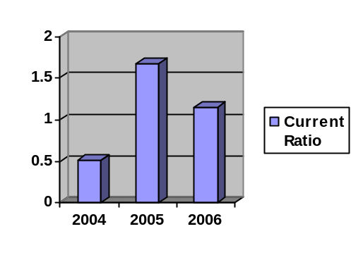
Quick Ratio:
This ratio also measure company liquidity position but inventory is subtracted from current asset because it is least liquidity current asset. Its measure the company’s ability to pay off short term obligations without relying on the sale of inventories. Gharibwal cement company quick ratio is not good in year 2004 and 2006 i.e. 0.43 and 0.96 times. But in 2005 company liquidity position is good.

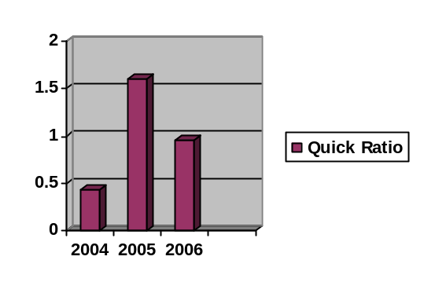
Cash Ratio:
Cash ratio can be interesting for short term creditors. Gharibwal cement company cash ratio is not good. Gharibwal have not enough cash to pay off its current liabilities. In recent three years, Gharibwal have less than 1 cash ratio.

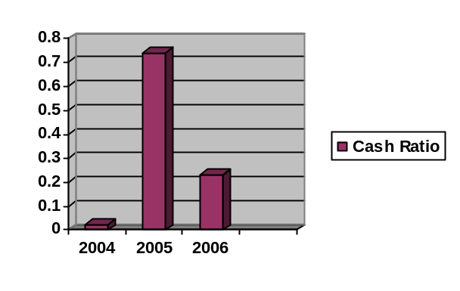
NWC to Asset:
NWC is viewed as the amount of short term liquidity a firm has. In year 2004 Gharibwal had negative NWC means its current liabilities exceeded current assets. In year 2005 it raised to 12% but goes down to 2% in year 2006. This indicates the relatively low level of liquidity.

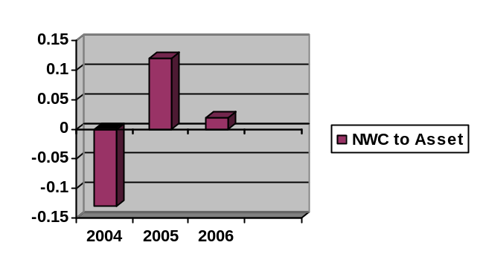
Interval Measure:
It measure how long company can operate until it need another financing? For Gharibwal interval for running is increasing. In year 2004 Gharibwal cement limited operate for 90.65 days or 2 months and in 2006 it goes to 238.51 days.
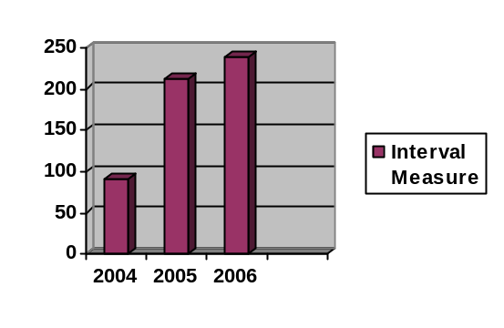

Asset Utilization Ratio
Inventory Turnover;
This ratio measure how many times inventory is sold out and restocked or turnover in a year? Gharibwal had high inventory turnover rate in year 2005 i.e. 54.55 times but low in year 2006 i.e. 9.68 times because inventory increased by 17.83% as compared to inventory in 2005.

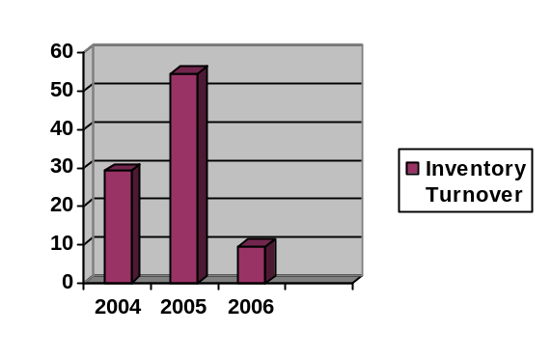
Days’ Sales In Inventory:
This ratio tells in how many days on average it takes to sold out inventory? Gharibwal cement limited, on average, in 2004 it took 13 days, in 2005 55 days and in 2006 38 days to sold out current inventory.
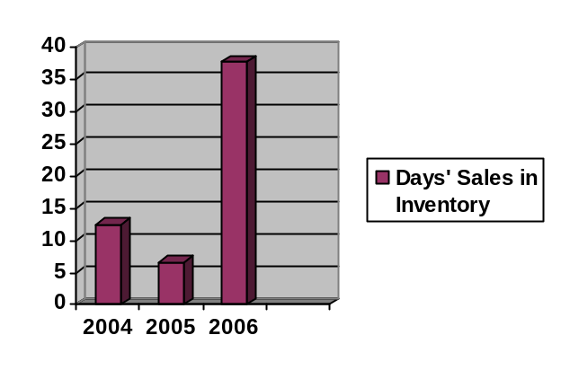
Receivables Turnover:
In this we measure how fast we collect outstanding credit account and re loaned the money? Gharibwal receivable turnover decreased from 2004 to 2006. In year 2004 20.67 times, in 2005 10.6 times and in 2006 12.13 times to collect it’s outstanding and re loaned its money. It shows Gharibwal cement limited is becoming fast to cover its outstanding and re loaned it.
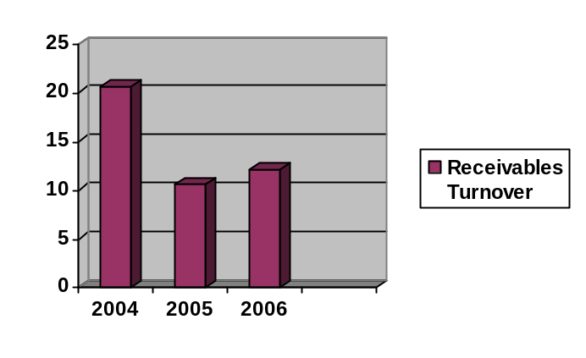
Days’ Sales in Receivables:
This ratio tells in how many days we collect credit sales? In this case Gharibwal days’ sales in inventory are increasing from year 2004 to 2006 i.e. 17.66 days to 30.09 days.

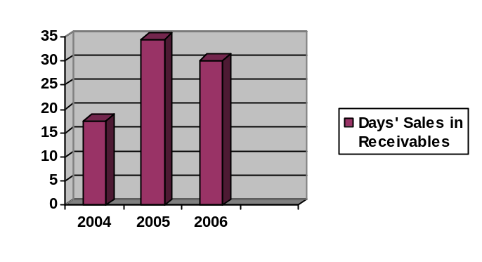
Fixed Asset Turnover:
It measures how effectively company uses its fixed assets to generate sales. In year 2006, Gharibwal cement limited generated Rs.0.63 for every rupee in fixed assets and it had more fixed assets than sales. Gharibwal fixed asset turnover was good in year 2005 as compared to year 2004 and year 2006.
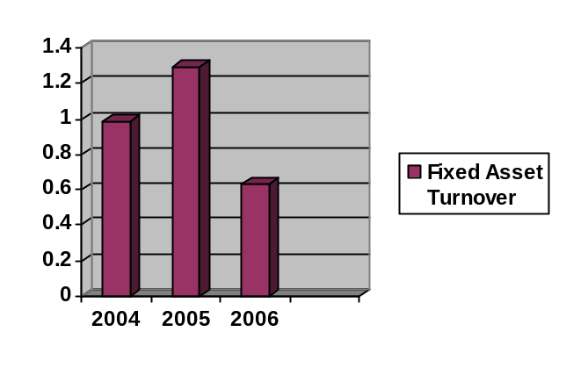
NWC Turnover:
This ratio measure how much work we get out of our working capital. A high value is preferred. Gharibwal’s NWC turnover value is increasing. In year 2004 it had negative net working capital but in 2005 it raised to 5.16times and in year 2006 it is 15.01 times. For every rupee in NWC Gharibwal generated Rs.15.01 in sales during year 2006.
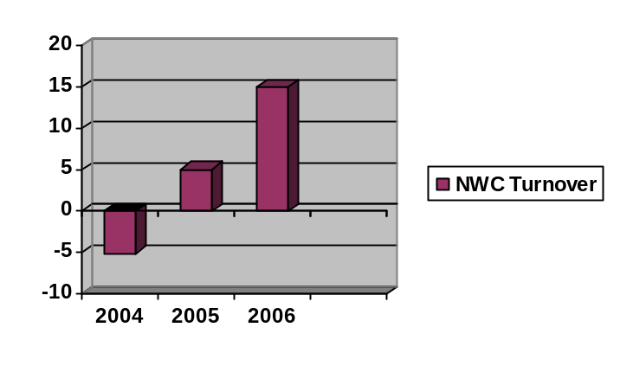

Long Term Solvency or Financial Leverage Ratio

Total Debt Ratio:
The debt ratio measures the percentage of the firm’s assets financed by the creditors (borrowing). Gharibwal cement limited company shows low debt ratio in year 2005 and year 2006 i.e. 34% and 26%, which provide cushion against creditors’ losses in the event of liquidation. Less chance for bankruptcy. In year 2004 Gharibwal had 68% in debt which was not good and more chance for bankruptcy.

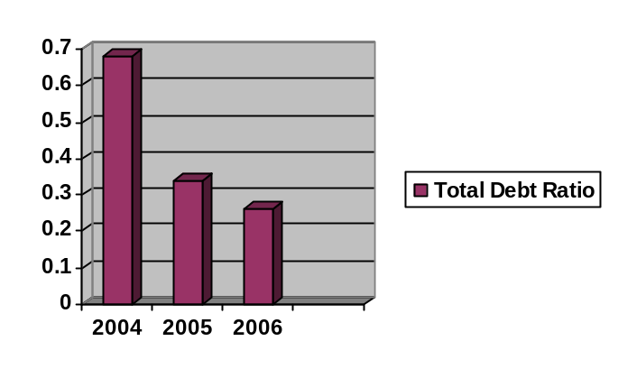

Debt Equity Ratio:
Debt equity ratio measure the financial leverage. Higher the debt equity ratio higher the financial leverage. A Gharibwal debt equity ratio is decreasing in recent three years and has lower financial leverage. Lower debt equity ratio means lower financial leverage and low risk associated with the company.

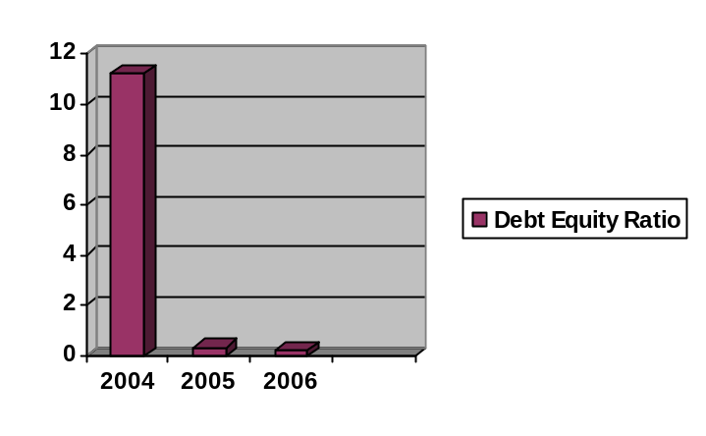
Time Interest Earned Ratio:
TIE ratio tells the ability of firms to meet its annual interest payments. Gharibwal TIE ratio is rising in recent three years. In 2006, Gharibwal’s interest is covered 5.24 times.
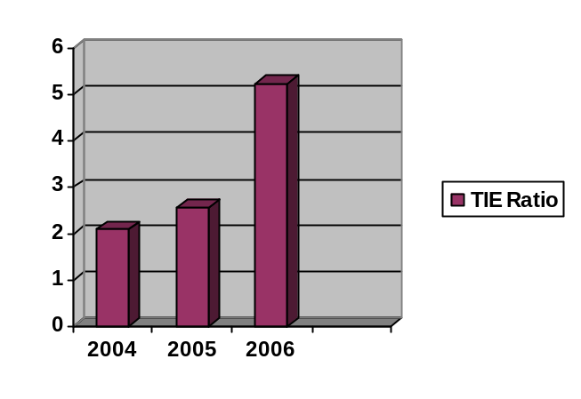
Cash Coverage Ratio:
This ratio measure firms ability to generate cash from operations or cash flow available to meet financial obligations. In this case Gharibwal’s cash coverage ratio is increasing from year 2004 to 2005 i.e. 3.26 to 6.5.
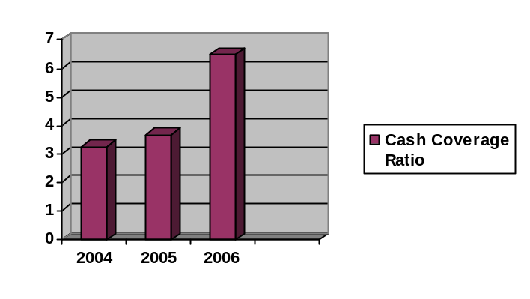

Profitability Ratios
Profit Margin:
This ratio tells the ability of firm to generate profit. Gharibwal’s profit margin is above 10% in recent three years which is relatively fair. In year 2006, Gharibwal generating Rs.0.11 in profit for every rupee in sales.
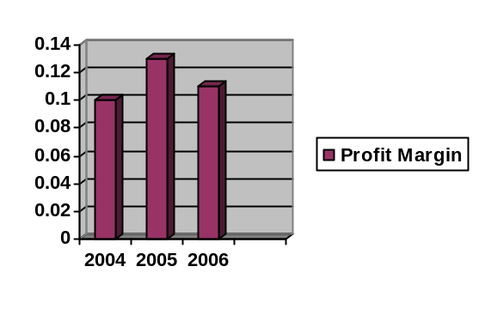
Return on Asset:
ROA measure of profit per rupee of assets. Low return of debt in recent three years.
Return on Equity:
ROE measure the rate of return on common stockholder’s investment. ROE objective is stockholder’s wealth maximization.

Market Value Ratios

Price Earning Ratio:
This ratio measures how investors are willing to pay per rupee of current earnings. Gharibwal cement limited earning price ratio is increasing. The investors are willing to invest. Higher price earning ratio is a sign of future growth.
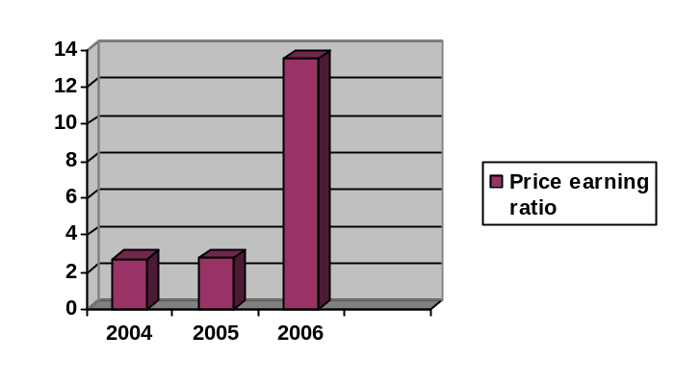
Net worth of Gharibwal Cement Limited:
Net worth of company = total asset – total liabilities

- Rs.3162536
- Rs.1606222
- Rs.573279
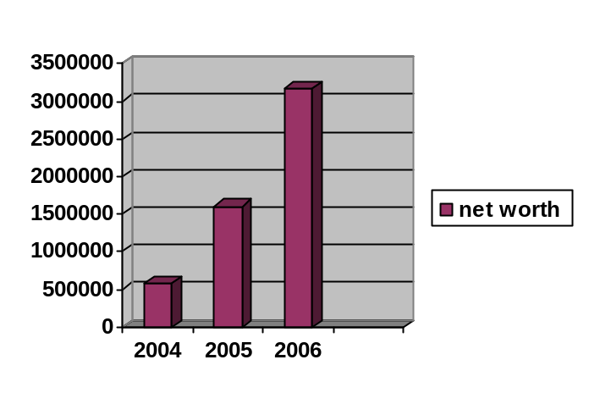

COMPARISION OF BOOK VALUE AND MARKET VALUE OF SHARE PRICE :

BOOK VALUE = TOTAL STOCK HOLDER EQUITY
NUMBER OF SHARES OUTSTANDING

YEAR | STOCK HOLDER | NUMBER OF SHARE | BOOK | MARKET
 | EQUITY | OUTSTANDING | VALUE | VALUE
2004 | 66,875,000 | 171,876,417 | 38.9 | 16.45
2005 | 114,743,000 | 171,876,417 | 66.8 | 11.95
2006 | 2,035,466,000 | 171,876,417 | 1,184.3 | 13.2

TREND IN CHANGE OF NETINCOME:

CHANGE IN INCOME = CURRENT YEAR – PREVIOUS YEAR X 100
PREVIOUS YEAR

YEAR | NET INCOME | % CHANGE IN
2003 | (199,765)
2004 | 115,323 | (157.73)
2005 | 188,878 | 63.78
2006 | 167,155 | (11.50)

FIRM TAXBARCKET AND AVERAGE TAX:

AVG TAXATION OF THE COMPANY = TOTAL TAX X 100
EBT

YEAR | TOTAL CURRENT | EBT | AVG TAX
 | TAX (Rs. In 000)
2004 | 9,962 | 112,894 | 8.82
2005 | 7,500 | 196,378 | 3.82
2006 | 3,090 | 170,245 | 1.82

DIVIDEND POLICY, RETENTION RATE, GROWTH RATE:

PAY OUT RATIO:

PAYOUT RATIO = DIVIDEND X 100
EPS

YEAR | DIVIDEND | EPS | PAYOUT RATIO
2004 | 0 | 5.09 | 0
2005 | 0 | 5.12 | 0
2006 | 0.5 | 1.09 | 0.46

RETENTION RATE:

RETENTION RATE = (1 – PAYOUT RATIO)*100

YEAR | PAYOUT RATIO | RETENTION RATE
2004 | 0 | 1
2005 | 0 | 1
2006 | 0.45 | 0.54

RETURN ON EQUITY:

RETURN ON EQUITY = NETINCOME X 100
TOTAL EQUITYS

YEAR | NET INCOME | TOTAL EQUITY | RETURN ON
 |  |  | EQUITY
2004 | 115,323 | 66,875 | 1.72
2005 | 188,878 | 114,743 | 1.65
2006 | 167,155 | 2,035,466 | 0.08

GROWTH RATE:

GROWTH RATE = (RETENTION RATE X RETURN ON EQUITY) X 100

YEAR | RETENTION | RETURN ON | GROWTH
 | RATE | EQUITY | RATE
2004 | 1.00 | 1.72 | 1.72
2005 | 1.00 | 1.65 | 1.65
2006 | 0.54 | 0.08 | 0.04

LAST YEAR YIELD:

DIVIDEND YIELD = DIVIDEND PER SHARE
MKRKET PRICE PER SHARE

YEAR | DIVIDEND PER | SHARE MARKET | LAST YEAR
 | SHARE | PRICE | YIELD
2003 | 0 | 6.25
2004 | 0 | 16.45 | 0
2005 | 0 | 11.95 | 0
2006 | 0.5 | 13.2 | 4.18

CAPITAL GAIN YIELD:

YEAR | SHARE MARKET | CAPITAL GAIN
 | PRICE
2003 | 6.25
2004 | 16.45 | 163.2
2005 | 11.95 | -27.36
2006 | 13.2 | 10.46

CAPM:

RF+β (Rm-Rf)

Rf = 8.85%
β = 0.23
Rm - Rf = 8%

8.85%+0.23*(8%)

Expected rate of return = 0.11

DIVIDEND DISCOUNT MODEL:

Po = D1+P1/1+r
YEAR | DIVIDEND PER | SHARE MARKET | EXPECTED RATE | DIVIDEND DISCOUNT
 | SHARE | PRICE | OF RETURN | MODEL
2004 | 0 | 16.45 | 0.11 | 16.43
2005 | 0 | 11.95 | 0.11 | 11.94
2006 | 0.5 | 13.2 | 0.11 | 13.68

ACTUAL RATE OF RETURN:

ACTUAL RATE OF RETURN = CAPITAL GAIN YIELD + DIVIDEND YIELD

YEARS | CAPITAL GAIN | LAST YEAR YIELD | ACTUAL RATE
 |  |  | OF RETURN
2004 | 163.2 | 0 | 163.2
2005 | -27.36 | 0 | -27.36
2006 | 10.46 | 4.18 | 14.64

INFINITE DIVIDEND PAYMENT:

Po = D1/r

YEARS | DIVIDEND PER | EXPECTED RATE | INFINITE DIVIDEND
 | SHARE | OF RETURN | PAYMENT
2004 | 0 | 0.11 | 0
2005 | 0 | 0.11 | 0
2006 | 0.5 | 0.11 | 454.55

BREAK EVEN RUPEES:

BREAK EVEN = FIXED COST
1 – VARIBLE COST
SALES

YEARS | SALES | FIXED COST | VARIBLE COST | BREAK EVEN RUPEES
2004 | 1,164,889.00 | 91,953.00 | 1,069,248.00 | 1,119,969.87
2005 | 1,469,504.00 | 116,686.00 | 1,319,885.00 | 1,146,047.92
2006 | 1,588,439.00 | 226,949.00 | 1,313,642.00 | 1,311,858.00

DEGREE OF OPERATING LEVERAGE:

OPERATING LEVERAGE = 1+ FIXED COST
EBIT

YEARS | FIXED COST | EBIT | DOL
2004 | 91953 | 91953 | 2.000
2005 | 116686 | 116686 | 2.000
2006 | 226949 | 226949 | 2.000

COMPARISON OF REQUIRED RATE OF RETURN WITH ACTUAL RATE OF RETURN:

YEARS | EXPECTED RATE | ACTUAL RATE
 | OF RETURN | OF RETURN
2004 | 0.11 | 16.3
2005 | 0.11 | -27.36
2006 | 0.11 | 14.64

COMPARISON OF ACTUAL PRICE WITH CALCULATED PRICE:

YEARS | SHARE MARKET | CALCULATED
 | PRICE | PRICE
2004 | 16.45 | 38.900
2005 | 11.95 | 66.800
2006 | 13.2 | 1,184.300

WEIGHTED AVERAGE COST OF CAPITAL:

 | 2006 | 2005 | 2004
EQUITY | 2,035,466 | 1,114,743 | 66,875
DEBT | 469,249 | 411,096 | 780,654
TOTAL CAPITAL | 2,504,715 | 1,525,839 | 847,529
WEIGHT OF EQUITY | 0.81 | 0.73 | 0.08
WEIGHT OF DEBT | 0.19 | 0.27 | 0.92
COST OF EQUITY | 0.11% | 0.11% | 0.11%
COST OF DEBT | 18.73 | 26.94 | 92.11
WACC | 2.28 | 4.72 | 55.15

GHRRIBWAL CEMENTS
BETA CALCULATION
Month |  | KSE 100 index |  | Share Price
Jun-06 |  | 9,989.41 |  | 13.20
May-06 |  | 9,800.69 |  | 12.60
Apr-06 |  | 11,342.17 |  | 15.80
Mar-06 |  | 11,485.90 |  | 17.55
Feb-06 |  | 11,456.27 |  | 14.25
Jan-06 |  | 10,524.16 |  | 14.45
Dec-05 |  | 9,556.61 |  | 14.30
Nov-05 |  | 9,025.93 |  | 15.55
Oct-05 |  | 8,247.34 |  | 11.20
Sep-05 |  | 8,225.66 |  | 10.90
Aug-05 |  | 7,796.86 |  | 8.85
Jul-05 |  | 7,178.93 |  | 9.45
Jun-05 |  | 7,450.12 |  | 11.95
May-05 |  | 6,857.67 |  | 9.70
Apr-05 |  | 7,104.65 |  | 10.30
Mar-05 |  | 7,770.33 |  | 11.30
Feb-05 |  | 8,260.06 |  | 11.00
Jan-05 |  | 6,747.39 |  | 16.35
Dec-04 |  | 6,218.40 |  | 14.60
Nov-04 |  | 5,567.79 |  | 14.30
Oct-04 |  | 5,332.24 |  | 13.60
Sep-04 |  | 5,217.65 |  | 15.40
Aug-04 |  | 5,346.15 |  | 14.25
Jul-04 |  | 5,289.92 |  | 12.55
SDm | 2,038.48
SDs |  | 2.35
CV | 1,100.73
β | 0.23

RECOMMENDATIONS:

Gharibwal Cement limited liquidity position is fair not good. There quick acid ratio is poor. Company has less cash in its account to pay its current liabilities. It has to cover its account receivables without selling its inventory. Gharibwal has low level of liquidity.
Gharibwal cement limited asset utilization is improving in recent three years. Less risk is associated with Gharibwal. Financial leverage is low. The profit margin is above 10%, which is fair. The condition of the company is less attractive for investor.

Future Prediction:
There is chance of growth for a Gharibwal Cement Limited because of price earning ratio is positive.

BIBLIOGRAPHY:

www.kse.com.pk

www.lse,com.pk

www.ghribwalcement.com

http://www.brecorder.com/index.php?currExchange=K&currPageType=D&currSector=15&stocks=stocks%2Fmframe.php&currDate=2006-06-30&scrType=800%7C600

